<SweatForSuccess >

Version <1.0>

Table of Contents

1. Introduction 4

1.1 Purpose 4

1.2 Scope 4

1.3 Definitions, Acronyms, and Abbreviations 4

1.4 References 4

1.5 Overview 4

2. Architectural Representation 4

3. Architectural Goals and Constraints 4

4. Use-Case View 4

4.1 Use-Case Realizations 5

5. Logical View 6

5.1 Overview 6

5.2 Architecturally Significant Design Packages 6

6. Process View 6

7. Deployment View 6

8. Implementation View 7

8.1 Overview 7

8.2 Layers 7

9. Data View (optional) 7

10. Size and Performance 7

11. Quality 7

# Introduction

## Purpose

This document provides a comprehensive architectural overview of the system, using a number of different architectural views to depict different aspects of the system. It is intended to capture and convey the significant architectural decisions which have been made on the system.

## Scope

This document defines the architecture of the system of the SweatForSuccess Android App specifies communication between the different components of the application.

## Definitions, Acronyms, and Abbreviations

|  |  |
| --- | --- |
| n/a | Not available |
| MVC | Model View Controller |
| UC | Use Case |

## References

|  |  |  |
| --- | --- | --- |
| Title | Date | Publishing Organization |
| [SweatForSuccess Blog](https://sweatforsuccess689030981.wordpress.com/) |  | SweatForSuccess |
| [SRS](https://github.com/ThSilv3r/Sweat4Success/blob/master/Software%20Requirement%20Specification.pdf) |  | SweatForSuccess |

## Overview

This project is based on the MVC pattern.

# Architectural Representation

This project is based on the MVC pattern.

# Architectural Goals and Constraints

The application uses MVC as architectural pattern to separate the backend logic form the user interface. Purpose of the controller is to enable communication between components. This includes updating the model and change view based on user interaction.

# Use-Case View

<https://app.diagrams.net/#G1bKyiwrzbFiEMzz4HD5FNjAwqQagxVz_z>

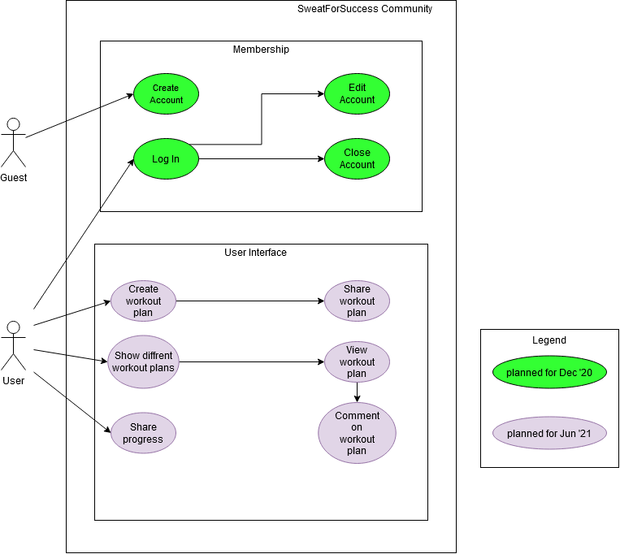

## Use-Case Realizations

* [UC Create Account](https://github.com/ThSilv3r/Sweat4Success/blob/master/UC/UCCreateAcount.md)
* [UC Create Workout](https://github.com/ThSilv3r/Sweat4Success/blob/master/UC/UCCreateWorkout.md)
* [UC Profil](https://github.com/ThSilv3r/Sweat4Success/blob/master/UC/UCProfil.md)
* [UC Comment Workout](https://github.com/ThSilv3r/Sweat4Success/blob/master/UC/UCcommentWorkout.md)
* [UC Search Workout](https://github.com/ThSilv3r/Sweat4Success/blob/master/UC/UCsearchWorkout.md)
* [UC Show List of Workouts](https://github.com/ThSilv3r/Sweat4Success/blob/master/UC/UCshowListOfWorkouts.md)
* [UC Show Workout](https://github.com/ThSilv3r/Sweat4Success/blob/master/UC/UCshowWorkout.md)

# Logical View

## Overview

## Architecturally Significant Design Packages

<https://github.com/ThSilv3r/Sweat4Success/blob/Nils/Package%20sweat4success.svg>

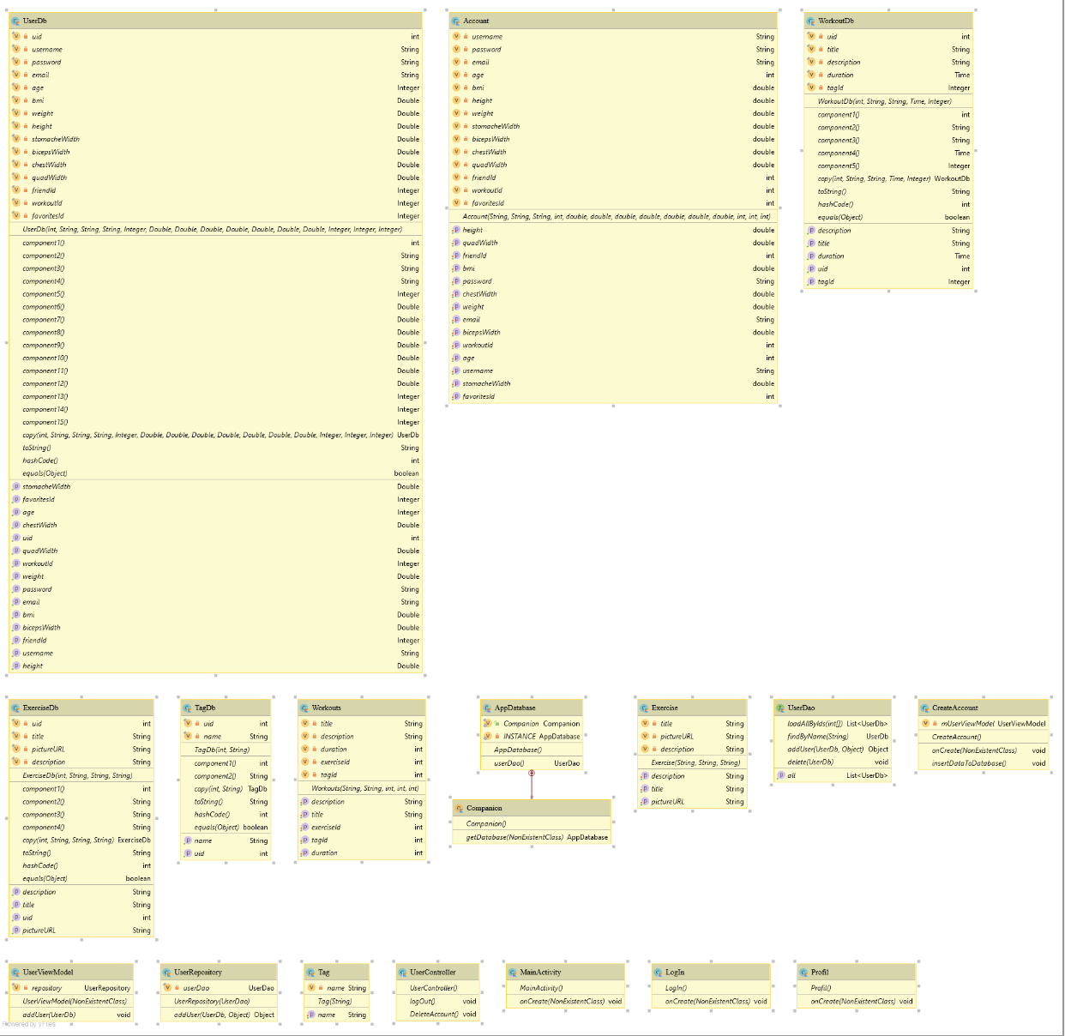

# Process View

n/a

# Deployment View

n/a

# Implementation View

n/a

## Overview

n/a

## Layers

n/a

# Data View

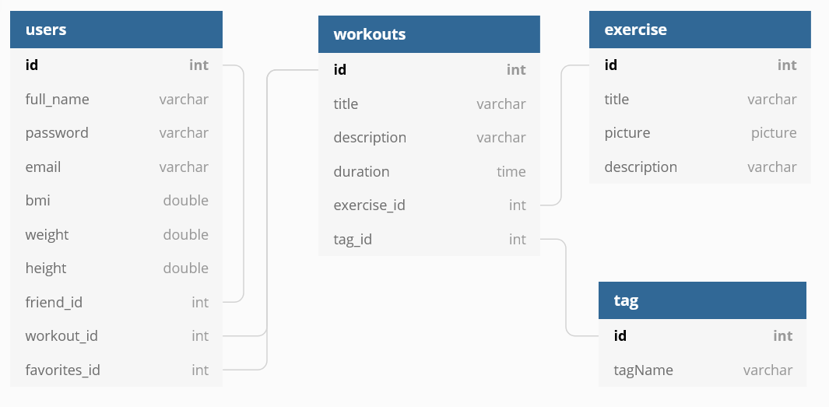

# Size and Performance

n/a

# Quality

n/a